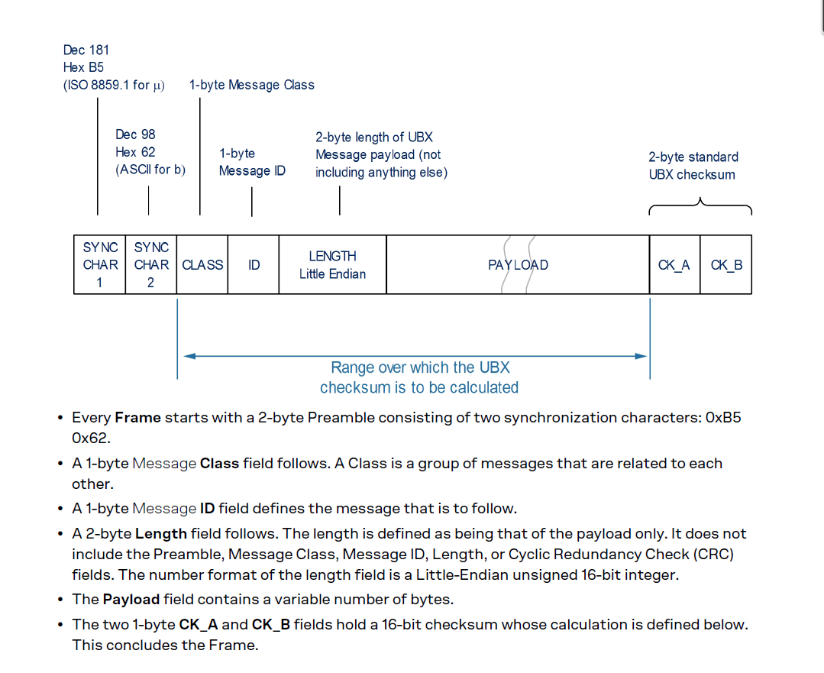
<All data is lil’endian>
TIM-Mark message:
prefix: B5 62 0D 03
length: 1C 00 28
0 ch: 00
1 flags: 4D time valid, new FE, running
2 count: BF 01 447
4 rewk#: 89 08 2185
6 fewk#: 89 08 2185
8 retow: 71 8D 5C 10 274 500.977
12 retowns: 31 8E 0E 00 953 905
16 fetow: 59 91 5C 10
20 fetowns: 20 8E 0E 00
24 accest: 1B 00 00 00
chksum: BF 0B

FLAGS: MODE 0x01 1 = running
RUN 0x02 1 = stopped
newFE 0x04 1 = new falling edge
TB 0x18 0 = rx time, 1 = GNSS time, 2 = UTC
UTC 0x20 1 = UTC available
TIMEVALID 0x40 1 = time valid
newRE 0x80 1 = new rising edge

Checksum:
CK_A = 0, CK_B = 0
for(i=0;i<N;i++)
{
CK_A = CK_A + Buffer[I] // “Buffer[0]” is [class/ID/len/payload]
CK_B = CK_B + CK_A
}

